Run the main.py and then the below window appears.

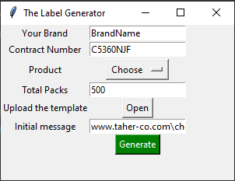

Insert your brand name, shorter is better, and make sure that you will choose the product as well.

The system will create extra 10 labels to cover damages if you need more then insert the number you feel safe.

You have to have a ready label, upload it into the system, system will ask you to select the ROI that you want to paste the QR-Code. (Bigger area will ease the QR code detection)

You can add the message before the unique code in the message code.

The generated code will be like

BRANDNAME-CONTRACTNUMBER-PRODUCT-UNIQUE NUMBER

And the generated QR-Code will be

INITIAL MESSAGE-BRANDNAME-CONTRACTNUMBER-PRODUCT-UNIQUE NUMBER

Result will be;

www.taher-co.com\checker\TAHER-C5360NJF-DRIED_FIGS-1023

If you want have any solid words or characters before the number you can insert it in the Initial message box.

Just press the Generate button and find the excel file carries all codes, qr codes and the final labels in the folder named generate in the main program folder.

Enjoy!